

CCS Internal Question Paper Solution

Internal Assessment Test 2 Scheme & Solution – May – 2026
Sub: | Cloud Computing and Security |  |  |  |  | Sub Code: | BIS613D | Branch: | ISE
Date: | 04.05.2026 | Duration: | 90 Min | Max Marks: | 50 | Sem / Sec: | VI / A, B & C (SET-1)

QN | Questions  Answer any 5 full questions | Marks | OBE
QN | Questions  Answer any 5 full questions | Marks | CO | RBT
1. | Explain inter-cloud resource management and its importance.  (Explanation 5m + Figure and Tables 5m)  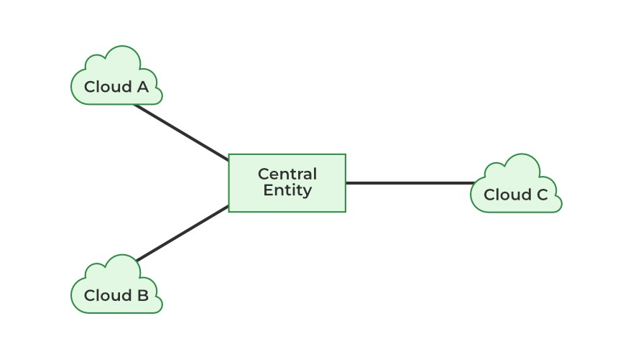  Inter-cloud resource management refers to the techniques and strategies used to coordinate, allocate, and optimize resources across multiple cloud environments.  This chapter explores cloud federation, multi-cloud strategies, resource orchestration, interoperability standards, Kubernetes-based container orchestration, and real-world case studies on cross-cloud deployment.  Cloud Federation and Multi-Cloud Strategies  Cloud Federation  • Cloud federation is a model where multiple cloud providers or data centers collaborate to share resources and workloads.  • Enables scalability, redundancy, and cost optimization.  • Common in government, research, and enterprise IT where resources are pooled for efficiency.  Multi-Cloud Strategy  A multi-cloud strategy involves using multiple cloud providers (AWS, Azure, GCP) to avoid vendor lock-in and improve availability, performance, and compliance.  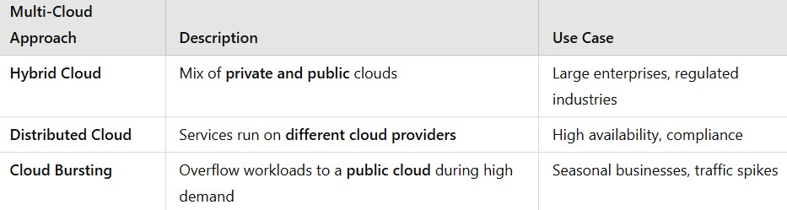  Benefits of Multi-Cloud Strategies  ✔ Avoids vendor lock-in – Organizations are not dependent on a single provider.  ✔ Improves redundancy – Ensures higher availability and failover capabilities.  ✔ Optimizes costs – Leverages cost differences between cloud providers.  ✔ Enhances performance – Deploy workloads in geographically closer data centers for lower latency.  Resource Allocation and Orchestration across Multiple Clouds  Challenges in Multi-Cloud Resource Management  • Different APIs and configurations across providers.  • Data transfer costs and latency when moving workloads.  • Security and compliance across different cloud environments.  • Auto-scaling and load balancing across distributed clouds.  Techniques for Efficient Resource Allocation  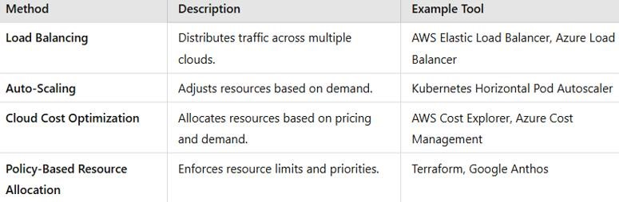 | 10 | CO3 | L2
2. | The CEO of Confident Solutions Mr Sarath, is planning to start a warehouse in his vacant land. The planned computing infrastructure requires a powerful server, high speed/bandwidth-based networking and computing/storage equipment. Instead of heavily investing in the infrastructure, Sarath decided to host all of them in the Cloud environment. Discuss and provide all the necessary infrastructure with suitable explanation for the design of the company's cloud solution.  (Explanation with key requirements and benefits - 10m)  What Sarath is trying to avoid—large upfront capital cost, maintenance overhead, and limited scalability—is exactly what cloud architecture is built to solve. A well-designed cloud setup can replace physical servers, networking gear, and storage systems while remaining flexible, secure, and cost-efficient.  Here’s how the cloud infrastructure for Confident Solutions can be designed:  1. Compute Infrastructure (Virtual Servers)  Instead of buying a powerful physical server, Sarath can use virtual machines (VMs) from cloud providers like Amazon Web Services, Microsoft Azure, or Google Cloud Platform.  Use services like EC2 (AWS) or Azure Virtual Machines  Choose high-performance instances (CPU/GPU based depending on workload)  Auto-scaling ensures more resources are added when demand increases  Benefit: No hardware purchase, pay only for usage, scalable instantly  2. Storage Infrastructure  Instead of local disks and storage servers:  Object Storage (e.g., Amazon S3) for warehouse data, logs, and backups  Block Storage for running applications  File Storage for shared access across systems  Benefits:  Virtually unlimited storage  High durability (data replicated across locations)  Easy backup and recovery  3. Networking Infrastructure  To replace high-speed physical networking:  Virtual Private Cloud (VPC) for isolated network environment  Subnets to separate public and private services  Load Balancers to distribute traffic efficiently  High bandwidth internet gateways for fast access  Benefits:  Secure and flexible networking  High-speed connectivity without physical setup  Traffic management improves performance  4. Database Services  Instead of maintaining database servers:  Use Managed Databases (e.g., AWS RDS, Azure SQL Database)  Supports SQL/NoSQL depending on needs  Benefits:  Automatic backups  High availability and replication  No manual maintenance  5. Security Infrastructure  Security must be built into the design:  Identity and Access Management (IAM) for user roles  Firewalls & Security Groups for access control  Encryption for data at rest and in transit  Monitoring & Logging tools  Benefits:  Strong access control  Compliance with security standards  Reduced risk of data breaches  6. Scalability & Elasticity  Cloud allows dynamic scaling:  Auto-scaling groups increase/decrease servers based on load  Useful for seasonal warehouse demand  Benefit:  No over-provisioning or under-utilization  7. Backup & Disaster Recovery  Automated backups and snapshots  Multi-region replication  Disaster recovery strategies  Benefit:  Business continuity even during failures  8. Cost Optimization  Pay-as-you-go model  Reserved instances for long-term savings  Monitoring tools to track usage  Benefit:  No upfront capital expenditure (CAPEX → OPEX)  9. Monitoring and Management  Tools like CloudWatch / Azure Monitor  Track system health, usage, and performance  Benefit:  Proactive issue detection  Improved reliability  10. Architecture Overview (Design Summary)  A typical cloud design for Confident Solutions would look like:  Users → Internet → Load Balancer  Load Balancer → Auto-scaled Virtual Machines  VMs → Managed Database + Cloud Storage  Entire system inside a secure VPC  Monitoring + Backup running in the background | 10 | CO3 | L3
3. | Describe the concept of cloud data encryption & its role in securing cloud storage.  (Explanation 6m + Figure 4m)  The government, large corporations, and individual users ponder if it safe to store sensitive information on a public cloud. Encryption is the obvious solution to protect outsourced data and cloud service providers have been compelled to offer encryption services. For example, Amazon offers AWS Key Management Service (KMS) to create and control the encryption keys used by clients to encrypt their data. KMS is integrated with other AWS services including EBS, S3, RDS, Redshift, Elastic Transcoder, and WorkMail. AWS also offers Encryption SDK for developers.  Homomorphic encryption. Sensitive data is safe while in storage, provided that it is encrypted with strong encryption. But encrypted data must be decrypted for processing and this opens a window of vulnerability. So a first question examined in this section is if it is feasible to operate on encrypted data. The homomorphic encryption, a long time dream of security experts, reflects the concept of homomorphism, a structure-preserving map f (·) between two algebraic structures of the same type see Figure 11.2  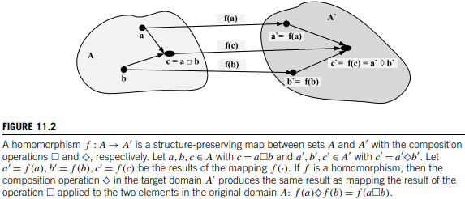  Searching encrypted databases is of particular interest. Several types of searches are frequently conducted including: single-keyword, multi-keyword, fuzzy-keyword, ranked, authorized, and verifiable search. Searchable symmetric encryption (SSE) is used when an encrypted databases E is outsourced to a cloud or to a different organization. SSE hides information about the database and the queries.  The client only stores the cryptographic key. To search the database the client encrypts the query, sends it to the database server, receives the encrypted result of the query and decrypts it using the cryptographic key. The information leakage from these searches is confined to query patterns, while disclosure of explicit data and query plaintext values is prevented.  An SSE protocol supporting conjunctive search and general Boolean queries on symmetrically encrypted data was proposed in [86]. This SSE protocol scales to very large databases. It can be used for arbitrarily structured data including free text search with the moderate and well defined leakage to the outsourced server. Performance results of a prototype applied to encrypted search over the entire English Wikipedia are reported. The protocol was extended with support for range, substring, wildcard, and phrase queries.  The next question is if sensitive data stored on the servers of a private cloud is vulnerable. The threat posed by an outsider attacker is diminished if the private cloud is protected by an effective firewall. Nevertheless, there are dangers posed by an insider. If such an attacker has access to log files it can infer the location of database hot spots, copy data selectively, and use the data for a nefarious activity. To minimize the risks posed by an insider, a set of protections rings should be enforced to restrict the access of each member of the staff to a limited area of the data base. | 10 | CO4 | L2
4. | Explain different cloud security defense strategies.  (Explanation 6m + Figure 4m)  A healthy cloud ecosystem is desired to free users from abuses, violence, cheating, hacking, viruses, rumors, pornography, spam, and privacy and copyright violations. The security demands of three cloud service models, IaaS, PaaS, and SaaS, are described in this section. These security models are based on various SLAs between providers and users.  Basic Cloud Security  Three basic cloud security enforcements are expected. First, facility security in data centers demands on-site security year round. Biometric readers, CCTV (close-circuit TV), motion detection, and man traps are often deployed. Also, network security demands fault-tolerant external firewalls, intrusion detection systems (IDSes), and third-party vulnerability assessment. Finally, platform security demands SSL and data decryption, strict password policies, and system trust certification. Figure 4.31 shows the mapping of cloud models, where special security measures are deployed at various cloud operating levels.  Servers in the cloud can be physical machines or VMs. User interfaces are applied to request services. The provisioning tool carves out the systems from the cloud to satisfy the requested service. A security-aware cloud architecture demands security enforcement. Malware-based attacks such as network worms, viruses, and DDoS attacks exploit system vulnerabilities. These attacks compromise system functionality or provide intruders unauthorized access to critical information.  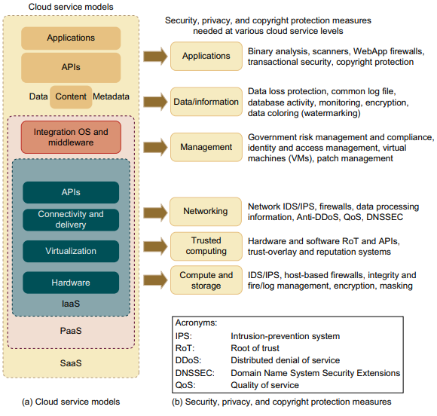  Thus, security defenses are needed to protect all cluster servers and data centers. Here are some cloud components that demand special security protection:  • Protection of servers from malicious software attacks such as worms, viruses, and malware  • Protection of hypervisors or VM monitors from software-based attacks and vulnerabilities  • Protection of VMs and monitors from service disruption and DoS attacks  • Protection of data and information from theft, corruption, and natural disasters  • Providing authenticated and authorized access to critical data and services | 10 | CO4 | L2
5. | How does Google App Engine (GAE) support cloud programming? Briefly Explain.  (Explanation 6m + Figure 4m)  Google App Engine (GAE) is a Platform as a Service (PaaS) for building and hosting web applications. Automatically handles scaling, load balancing, and infrastructure management. Supports apps written in multiple languages like Java, Python, Go and PHP.  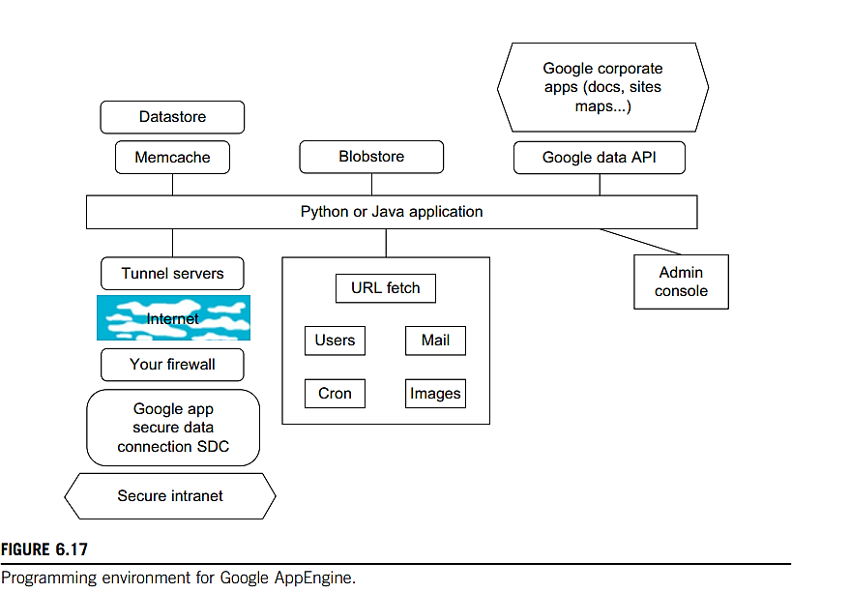  Central Component: Python or Java Application  - At the core of GAE, application is written in Python or Java.  - This central block communicates with various GAE services, such as storage, APIs, and communication modules.  Datastore, Memcache, and Blobstore  - Datastore: A NoSQL database where entities and properties are stored (schema-less).  - Memcache: An in-memory cache to speed up data retrieval and reduce datastore queries.  - Blobstore: Used to store large files (images, videos, docs) up to 2 GB.  Google Data API & Corporate Apps  - Google Data API: Enables your app to access other Google services (Docs, Maps, Calendar).  - Corporate Apps: These services (e.g., Google Docs, Sites, Maps) can be programmatically accessed via APIs.  URL Fetch and Internal Services  These services are called directly from the app:  - URL Fetch: Makes HTTP/HTTPS calls to external services.  - Users: Manages authentication via Google Accounts.  - Mail: Sends emails via Google's mail infrastructure.  - Cron: Schedules recurring tasks (daily reports, DB cleanup).  - Images: Provides image transformations (resize, crop, etc.).  Admin Console  - Allows developers to monitor, configure, and deploy applications.  - Provides logs, error tracking, and service configurations.  External Communication  Secure Intranet Access:  - Your app can access your private intranet systems securely using:  - Tunnel Servers (through Internet),Your firewall, and  - Secure Data Connector (SDC).  Internet  - Represents how external connectivity (e.g., calling public APIs, webhooks, or intranet via tunnels) happens.  - URL Fetch, tunnel servers, and data connectors use this path. | 10 | CO5 | L2
6. | Discuss the programming environment of Amazon AWS and its applications.  (Explanation 6m + Figure 4m)  - Amazon (like Azure) offers a Relational Database Service (RDS) with a messaging interface  - Elastic MapReduce capability is equivalent to Hadoop running on the basic EC2 offering  - Amazon has NOSQL support in SimpleDB  - Amazon does not directly support BigTable  - Amazon offers the Simple Queue Service (SQS) and Simple Notification Service (SNS)  - Auto-scaling enables you to automatically scale your Amazon EC2 capacity up or down according to conditions that you define  - Elastic load balancing automatically distributes incoming application traffic across multiple Amazon EC2 instances  - Both auto-scaling and elastic load balancing are enabled by CloudWatch which monitors running instances  - CloudWatch is a web service that provides customers with visibility into resource utilization, operational performance, and overall demand patterns  - Amazon was the first company to introduce VMs in application hosting  - The elastic feature of such a service is that a customer can create, launch, and terminate server instances as needed, paying by the hour for active servers.  - Amazon provides several types of preinstalled VMs. Instances are often called Amazon Machine Images (AMIs) which are preconfigured with operating systems based on Linux or Windows, and additional software.  - AMIs are the templates for instances, which are running VMs  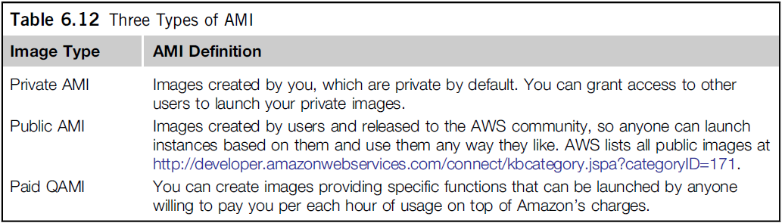  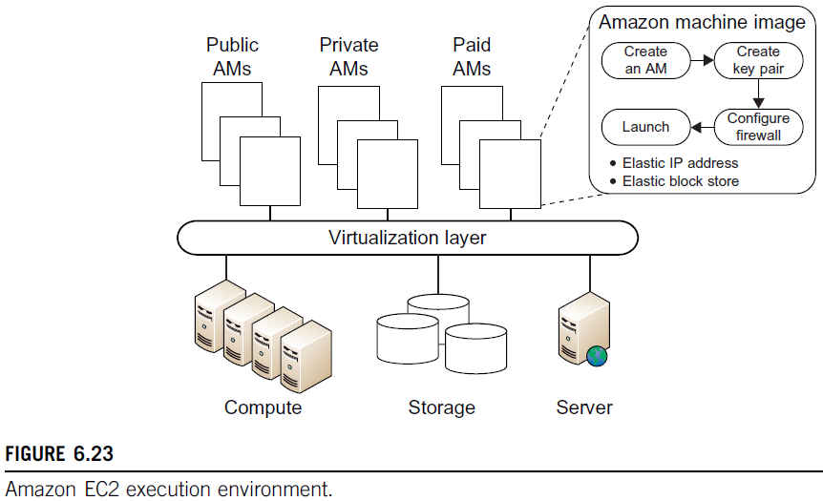 | 10 | CO5 | L3

CI CCI HOD-ISE

